Residency Application – 2020 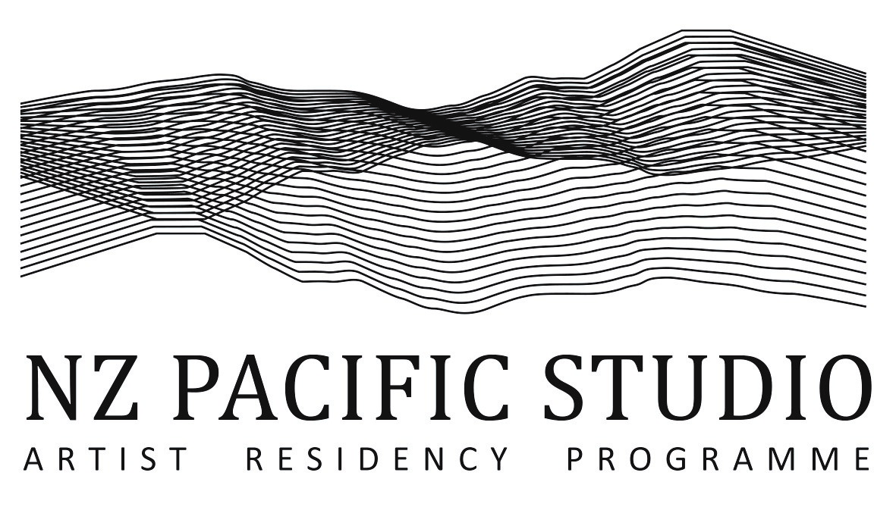
THANK YOU for your interest in NZ Pacific Studio. An award-winning programme founded in 2001, we have coordinated nearly 500 residencies. Residencies are self-funded (currently from NZ$420/week) and self-catering (residents prepare their own meals). For supported residencies, or Fellowships, please refer to this page of the website. Based at locations across Wairarapa, primarily self-contained cottages in rural areas, NZ Pacific Studio residents and fellows work intensively on a project of their own design.
NAME: DATE:
Country of residence: Email address:
MOBILE PHONE NUMBER: LINK TO WEBSITE (if any): SHORT BIOGRAPHY:

DESCRIPTION OF YOUR PROJECT that you will work on during the proposed residency:

PREFERRED DATES OF YOUR RESIDENCY: (minimum 2 weeks, maximum 3 months):
SPECIAL PROJECT REQUIREMENTS – such as studio space or equipment:
Note that few of our locations offer large studio space.
PREFERENCE AND NUMBER OF PEOPLE FOR ACCOMMODATION: Urban or Rural: Number of artists:
There will be a surcharge for an additional person. We do not accept children.
VEHICLE Will you have your own vehicle during the residency? Yes or No:
If not, a $70/week fee (plus petrol) applies. A vehicle is available if you have a current driver’s licence, in English.
COMMUNITY OUTREACH Are you interested to meet local artists during the residency? Yes or No:
Are you interested in offering an activity at a local school or community group? Yes or No:
CV / RESUME (please copy and paste here):
2-3 REPRESENTATIVE SAMPLES of your creative/academic work (please copy and paste here):
REFERENCES – Please provide contact details for 2 people who can vouch for your character and artistic integrity:
PLEASE EMAIL THIS APPLICATION in one document, under 3 mb, to info@artistresidency.org.nz.
If you do hear back from us within 3 weeks, please re-send your application. Thank you!
New Zealand Pacific Studio (CC22090) | PO Box 931 Masterton 5840 | www.artistresidency.org.nz

